**Bug ID:** 001

**Bug Name:**  P**assword format not defined while registering.**

**Severity:** 1-Critical

**Description:**  
**While registering, format of password to be used not mentioned, its only after entering password and submitting it tells about one of the format missing.**

**Steps To Reproduce:**  
**1)** Visit to <https://buggy.justtestit.org/>   
**2)** Click on the Register button on Top right corner.

**3)** Fill out the required fields and click Register.

**Expected Result:** While registering should ve defined the password template to tell user to make password as per the defined template.

**Actual Result: Lets user know the password does not meet standard.**

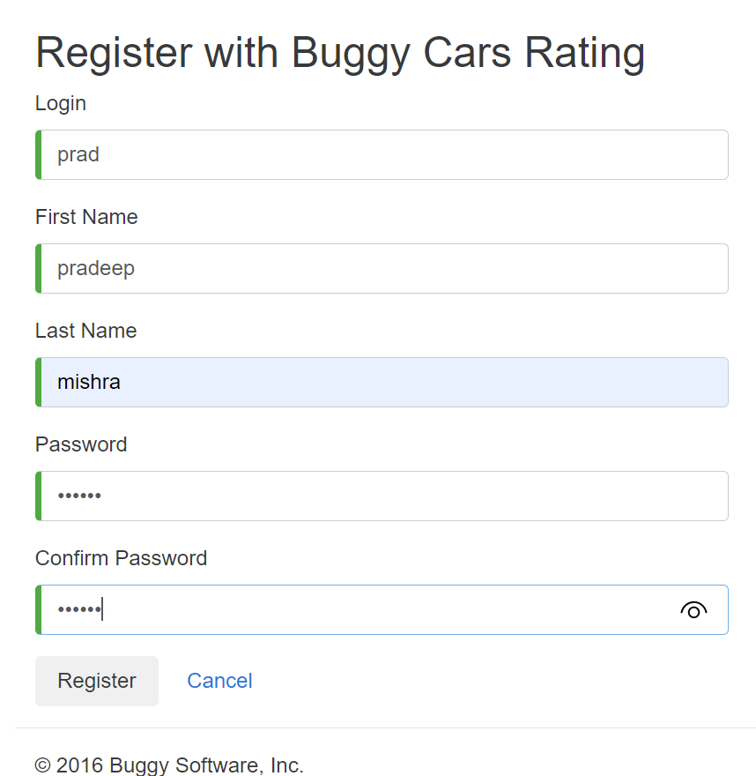

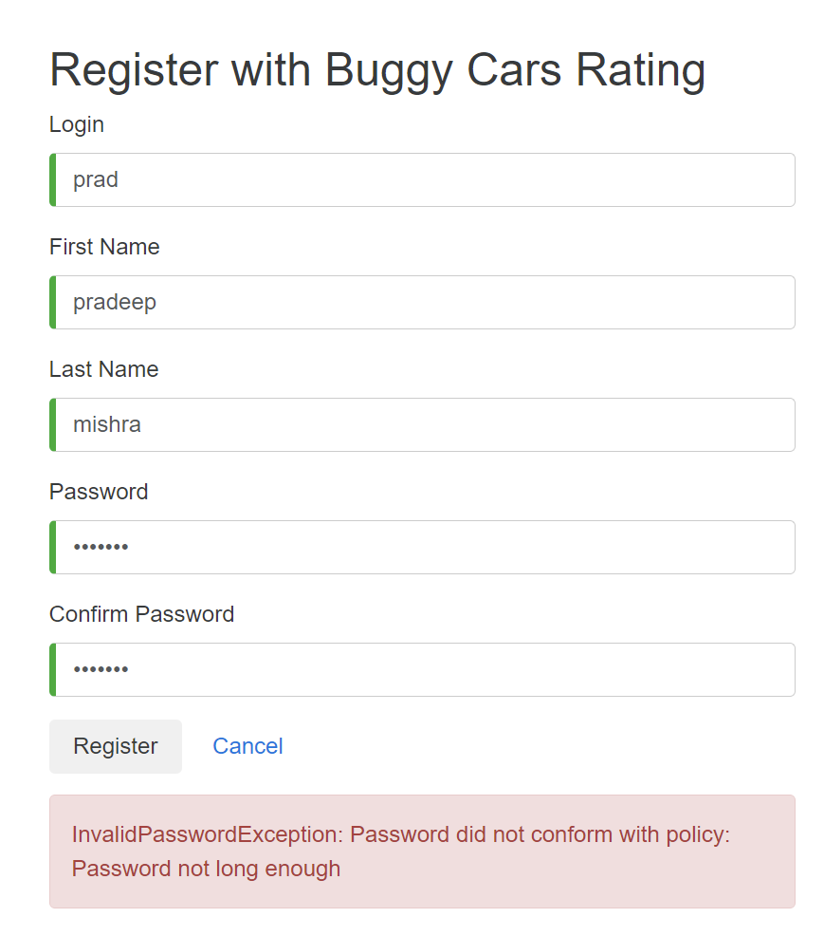

**Bug ID:** 002

**Bug Name:**  No way to get the forgot username / password.

**Severity:** 1-Critical

**Description:**  
**No way to get the forgot username / password.**

**Steps To Reproduce:**  
**1)** Visit to <https://buggy.justtestit.org/>   
**2)** Search for the forgot username or password link.

**Expected Result:** On page there should be option to get username and password registered before.

**Actual Result: No hyperlink to get forgot username / password on page.**

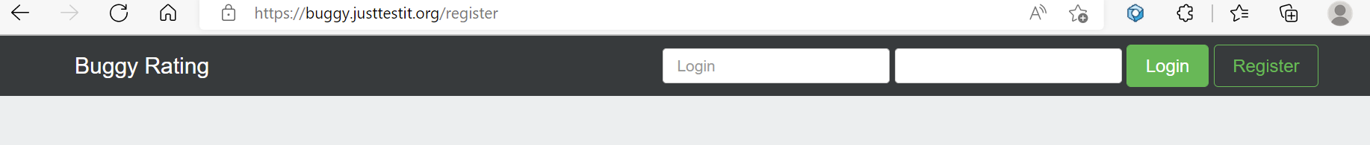

**Bug ID:** 003

**Bug Name:** “Popular model” page does not open in firefox browser.

**Severity:** 2-Major

**Description:**  
**Popular model page does not open in firefox browser.**

**Steps To Reproduce:**  
**1)** Visit to <https://buggy.justtestit.org/> on Firefox browser.  
**2)** Click on the “Popular model” link.

**Expected Result:** Popular Model link should load as in other browsers.

**Actual Result: Page does not load.**

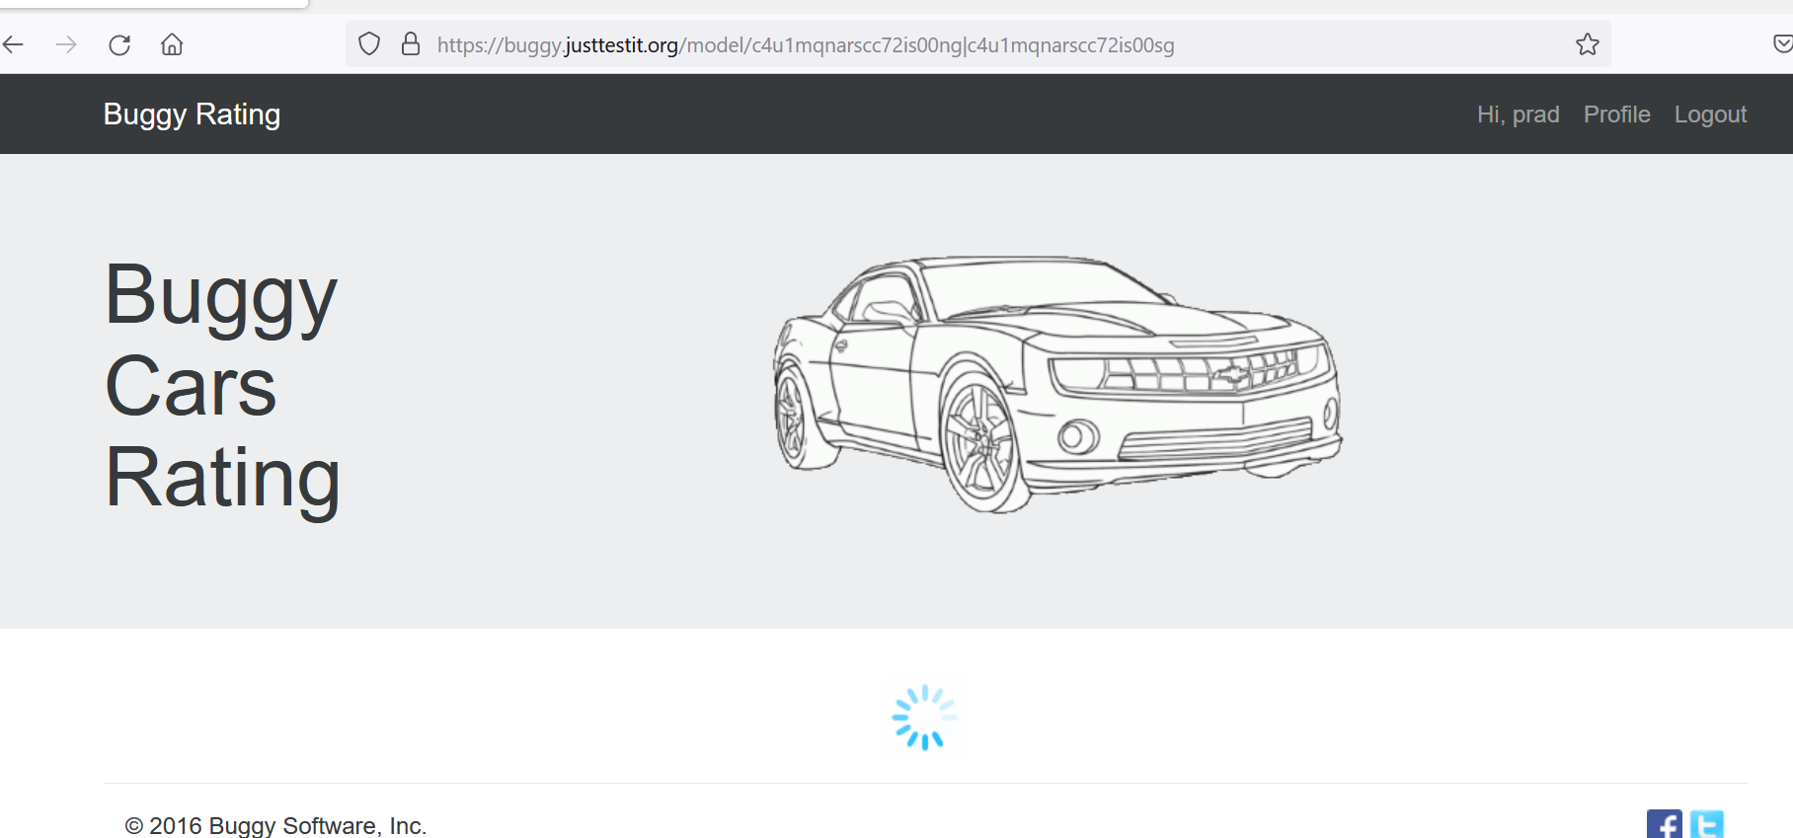

**Bug ID:** 004

**Bug Name:**  When comment is too long does not let user know how long comment can be.

**Severity:** 2-Major

**Description:**  
**When comment is too long does not let user know how long comment can be.**

**Steps To Reproduce:**  
**1)** Visit to <https://buggy.justtestit.org/> and login.  
**2)** click any car to vote with long comment.

**3)** Click Vote.

**Expected Result:** Does not define how long comment should be..

**Actual Result: Gives error as comment is too long.**

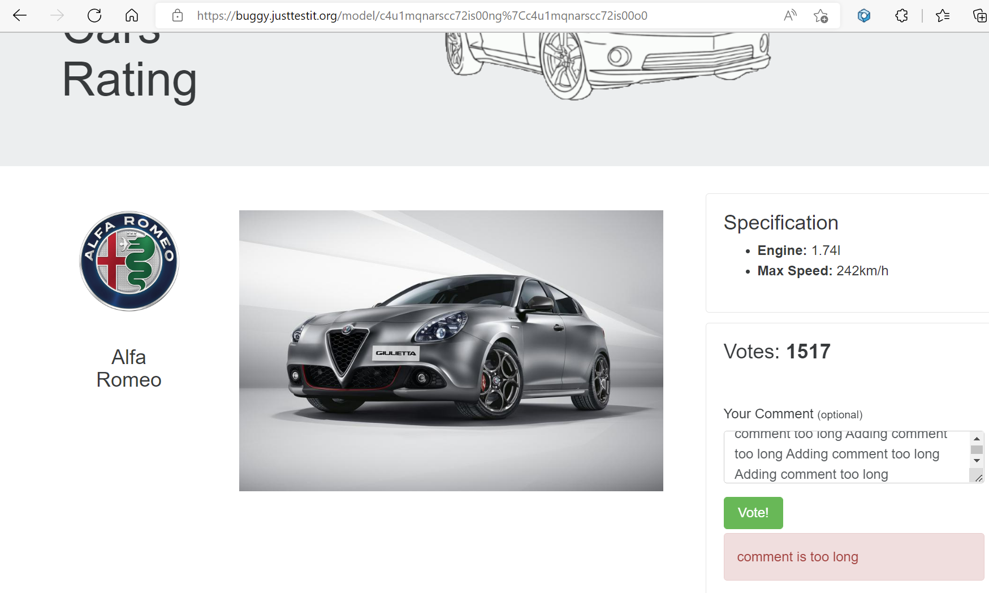

**Bug ID:** 005

**Bug Name:**  Rank sorting does not work properly on overall rating page.

**Severity:** 2-Major

**Description:**  
**Rank sorting does not work properly on overall rating page.**

**Steps To Reproduce:**  
**1)** Visit to <https://buggy.justtestit.org/> and login.  
**2)** Click on the “Overall Rating”.

**3)** Once on Overall rating page click Rank Heading to sort in descending order.

**Expected Result:** Once Rating heading clicked sorting should be in descending order.

**Actual Result: Ranking column show 1, 10, 11 etc rather than 21,20,19.**

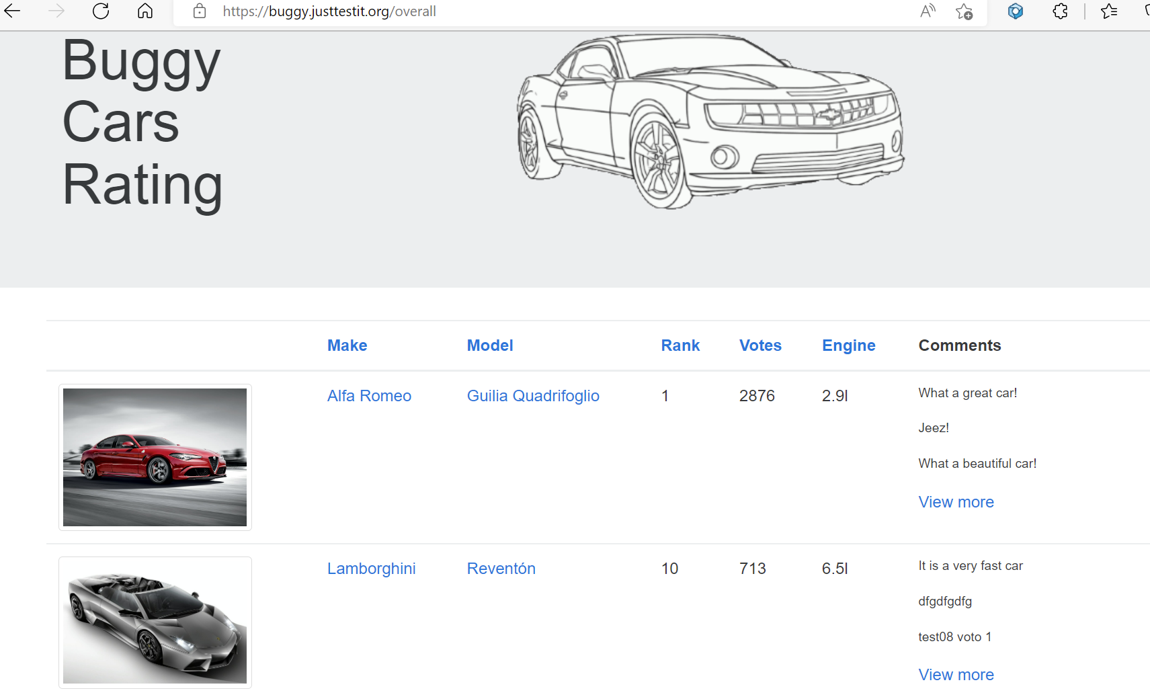

**Bug ID:** 006

**Bug Name:**  Facebook and twitter logo on bottom right takes to their respective home page to login rather than buggy cars facebook and twitter page.

**Severity:** 3-Moderate

**Description:**  
**Facebook and twitter logo on bottom right takes to their respective home page to login rather than buggy cars facebook and twitter page.**

**Steps To Reproduce:**  
**1)** Visit to <https://buggy.justtestit.org/> and login  
**2)** Click on the Facebook / Twitter logo on right bottom corner.

**Expected Result:** Should take to **buggy cars facebook and twitter page.**

**Actual Result: Takes to facebook / twitter respective home page to login.**

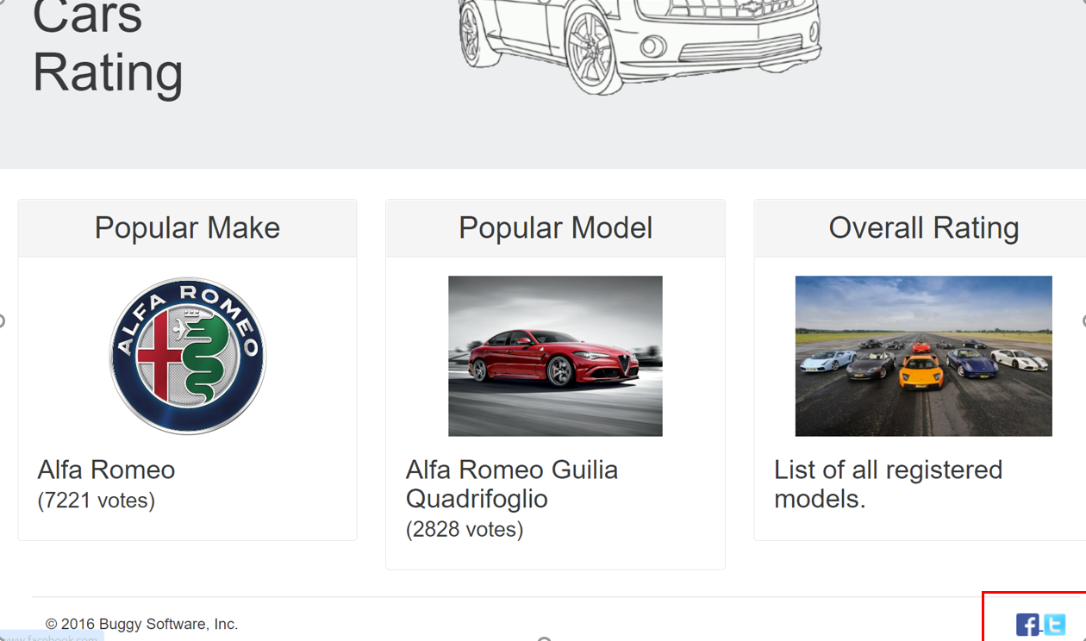

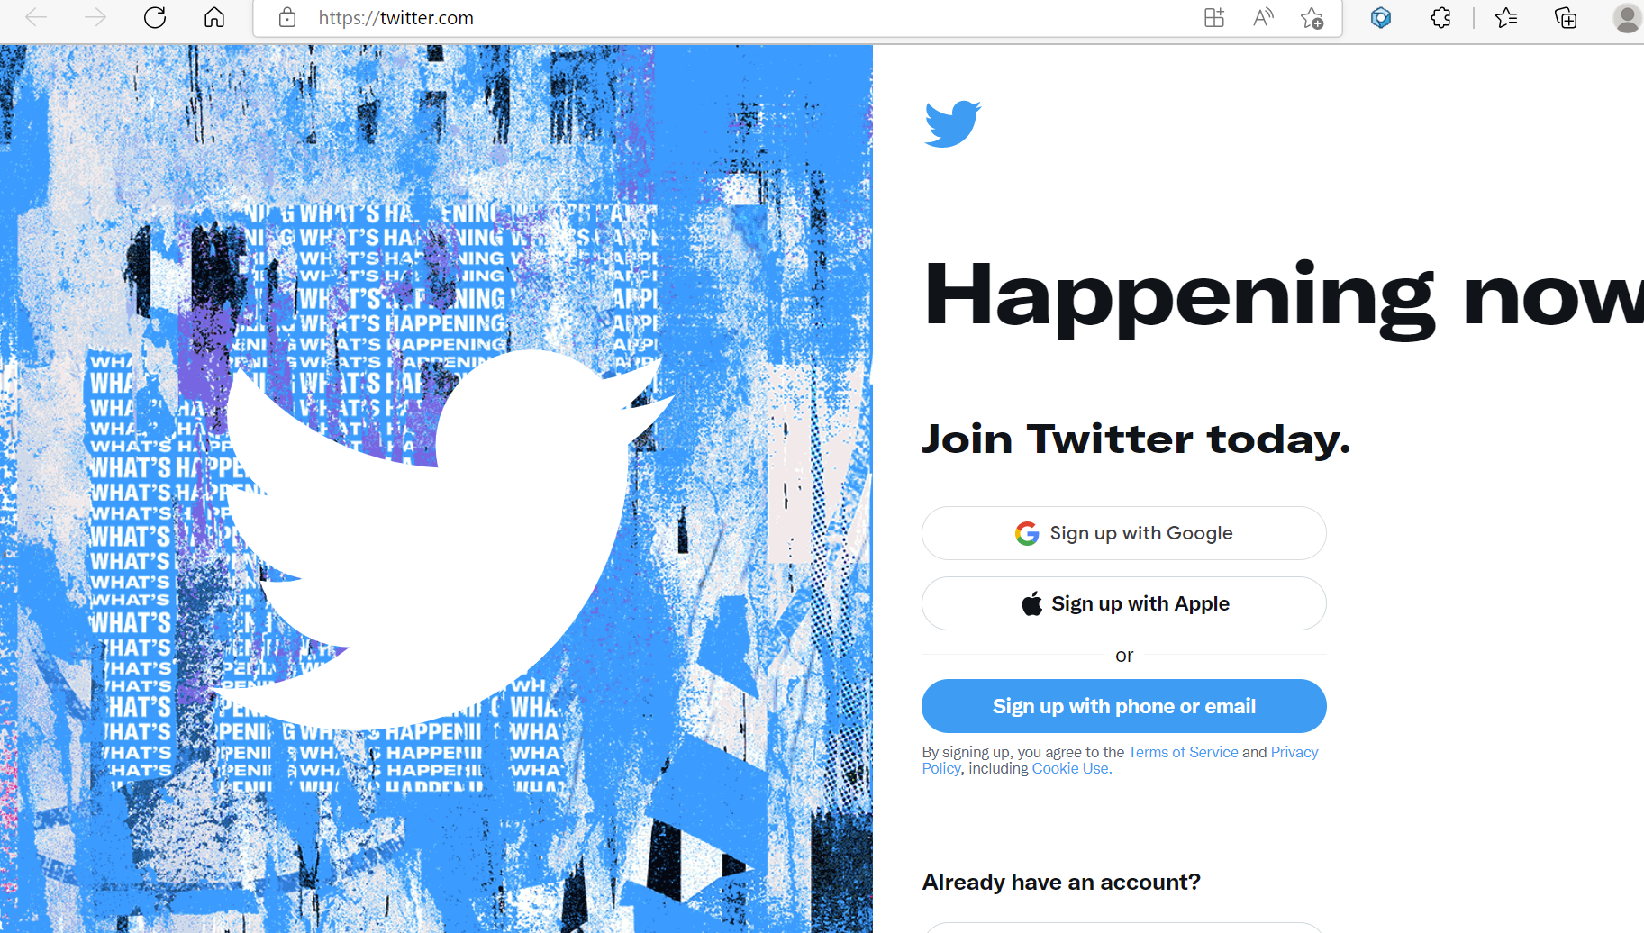

**Bug ID:** 007

**Bug Name:**  Author not displayed on popular model page.

**Severity:** 3-Moderate

**Description:**  
**Author not displayed on car model page.**

**Steps To Reproduce:**  
**1)** Visit to <https://buggy.justtestit.org/> and login.  
**2)** Click on overall rating and choose any car.

**3)** Scroll down for table where it shows comment about car and Date.

**Expected Result:** Author should have been displayed with username who has put the comment and voted.

**Actual Result: Author field is blank.**

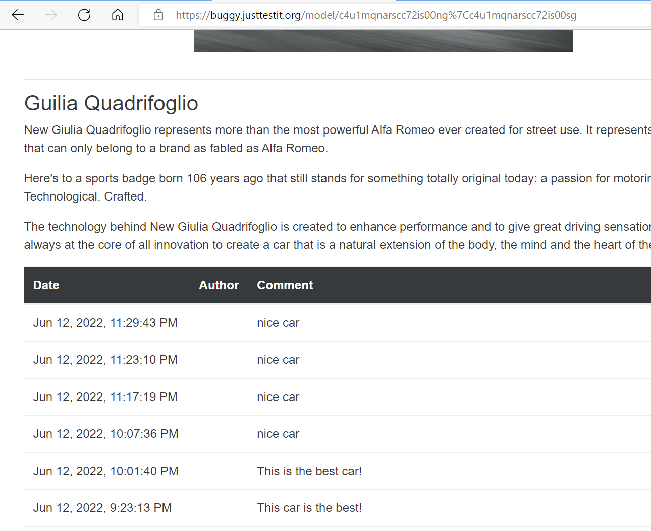

**Bug ID:** 008

**Bug Name:**  On “popular Make” page "Buggy Rating" logo on top left corner does not take to home page. **Severity:** 3-Moderate

**Description:**  
**"Buggy Rating" logo on top left corner On “popular Make” page does not take to home page.**

**Steps To Reproduce:**  
**1)** Visit to <https://buggy.justtestit.org/> and login.  
**2)** Click on the “Popular Make” logo in center of page.

**3)** Once on “Popular Make” page click on “Buggy Rating” logo on top left corner of page.

**Expected Result:** Once clicked "Buggy Rating" logo on top left corner should take to home page.

**Actual Result: Nothing happens and user still on same page, failure on bottom left corner of page says broken.**

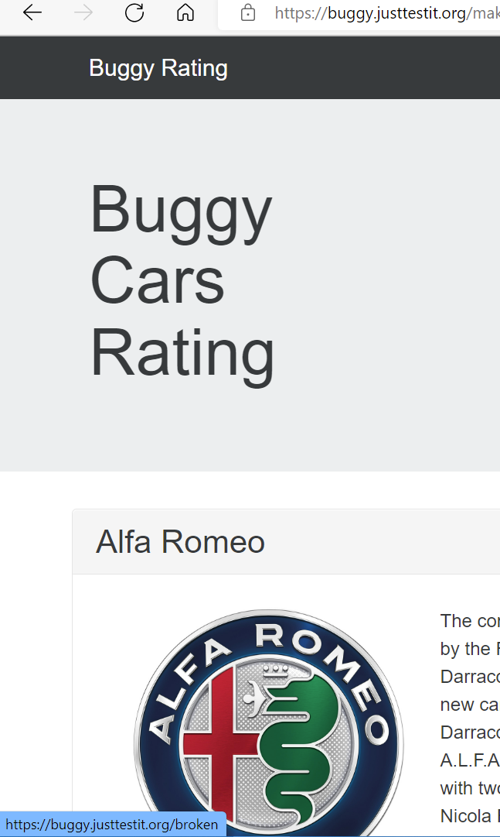

**Bug ID:** 009

**Bug Name:**  Make, model, Engine sorting is Ascending only on Overall rating page.

**Severity:** 3-Moderate

**Description:**  
**Make, model, Engine sorting is Ascending only on Overall rating page.**

**Steps To Reproduce:**  
**1)** Visit to <https://buggy.justtestit.org/> and login.  
**2)** Click on the “Overall Rating”.

**3)** Once on Overall rating page click Heading Make, Model, Engine to sort in descending order.

**Expected Result:** Once Heading button pressed once or twice it should sort in ascending and descending order.

**Actual Result: Does not sort in descending order.**

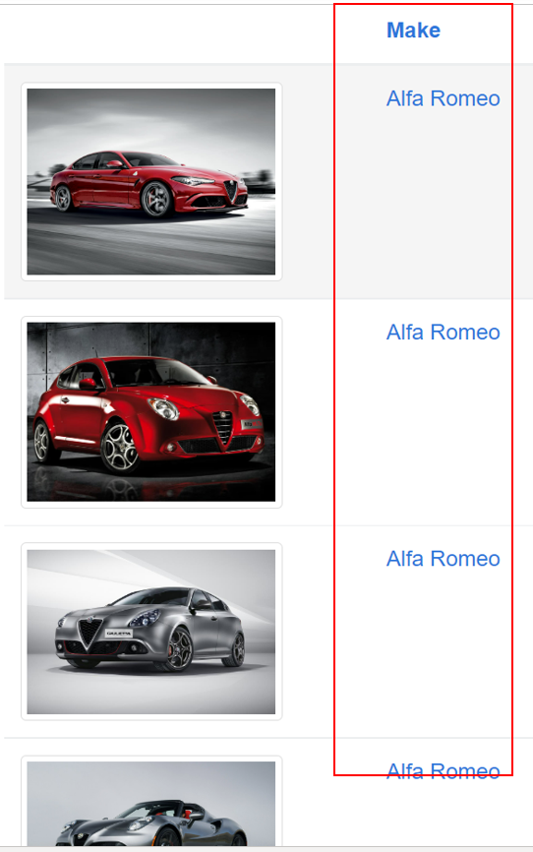

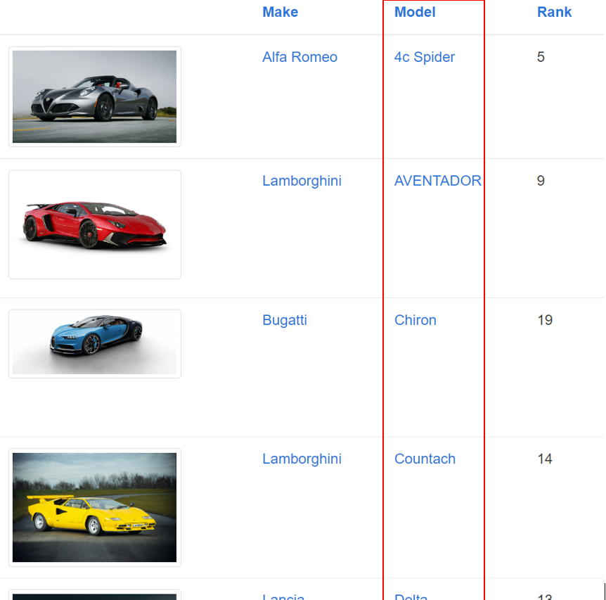

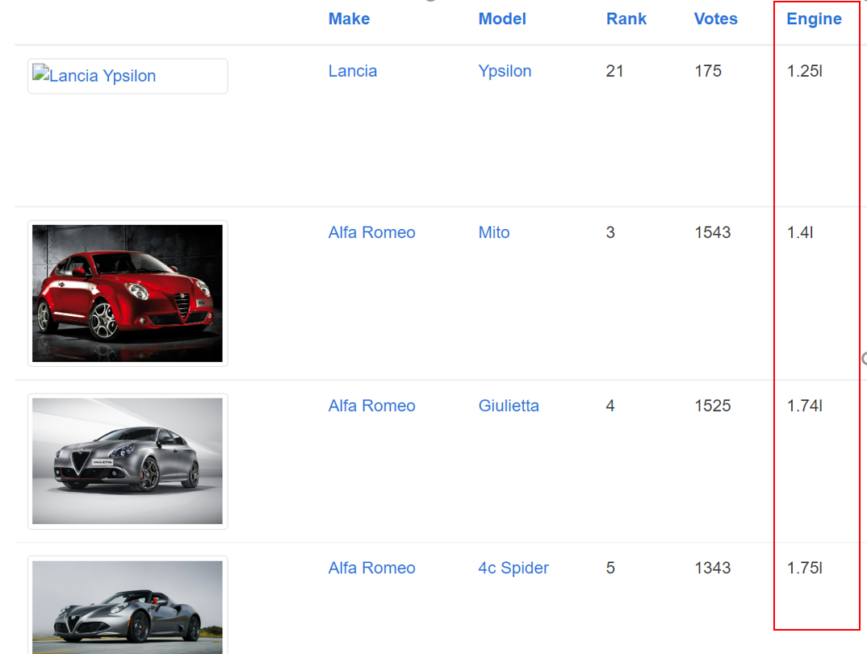

**Bug ID:** 010

**Bug Name:**  Votes sorting is Descending only on overall rating page.

**Severity:** 3-Moderate

**Description:**  
**Votes sorting is Descending only on overall rating page.**

**Steps To Reproduce:**  
**1)** Visit to <https://buggy.justtestit.org/> and login.  
**2)** Click on the “Overall Rating”.

**3)** Once on Overall rating page click Votes to sort in Ascending order.

**Expected Result:** Once Votes heading button pressed once or twice it should sort in ascending and descending order.

**Actual Result: Does not sort in Ascending order.**

**Bug ID:** 011

**Bug Name:**  Browser Back navigation does not work on Overall Rating page

**Severity:** 3-Moderate

**Description:**  
Once on Overall Rating page and moved to page 3 and browser Back button pressed it goes back to home page rather than page 2 of overall Rating.

**Steps To Reproduce:**  
**1)** Visit to <https://buggy.justtestit.org/> and login  
**2)** Click on the “Overall Rating”.

**3) Click** >> arrow on bottom of page to navigate to 3rd page.

4) Click Back browser button to go back to page number 2 of overall rating.

**Expected Result:** Once Back browser button click on page 3 should move to page number 2.

**Actual Result: Back button makes page go to home page.**

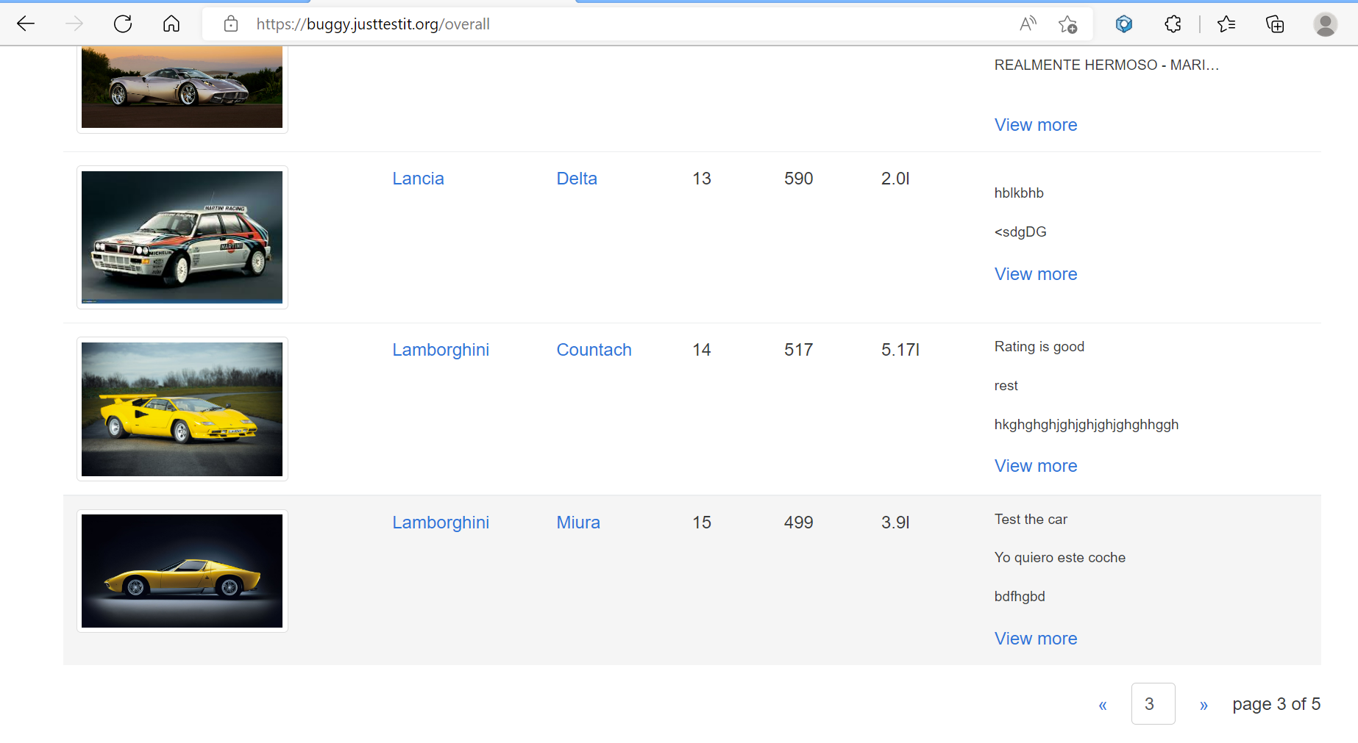

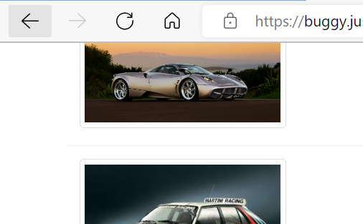

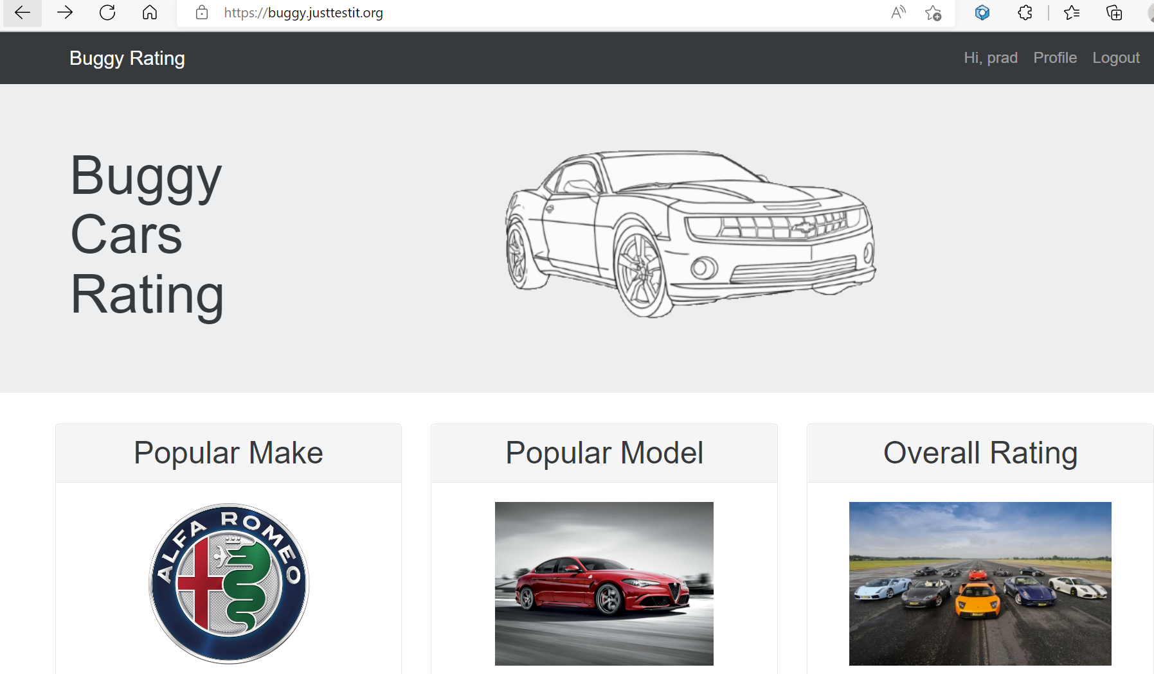

**Bug ID:** 012

**Bug Name:**  Age Field validation on profile page.

**Severity:** 3-Moderate

**Description:**  
Age Field validation on profile page, able to write character rather than number.

**Steps To Reproduce:**  
**1)** Visit to <https://buggy.justtestit.org/> and login  
**2)** Click on the “Profile”.

**3) Add any letter in age field and save it**.

**Expected Result:** In Age field only number should be allowed with validation..

**Actual Result: Able to type in any letters.**

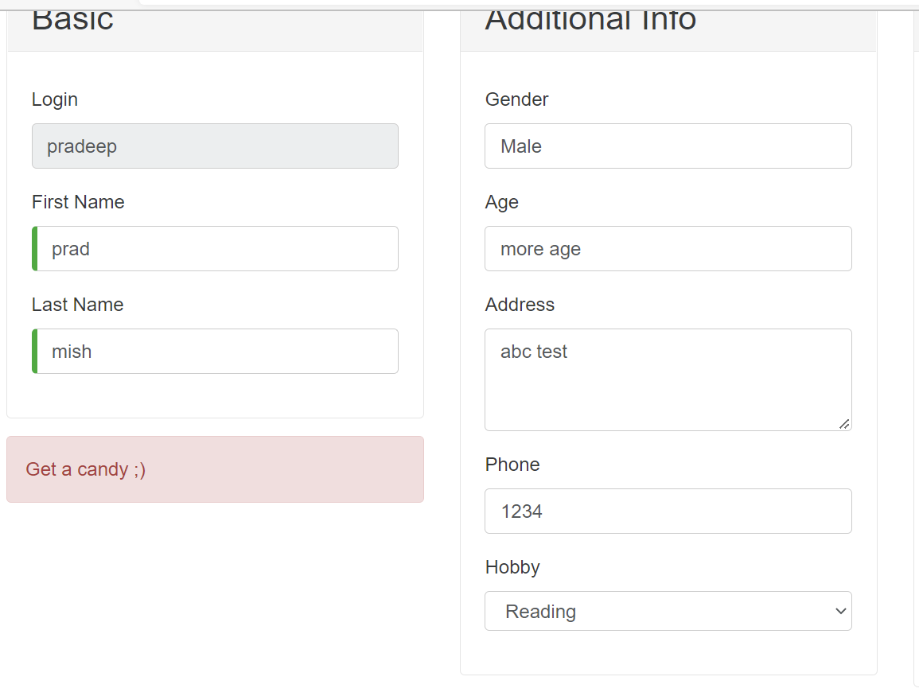

**Bug ID:** 013

**Bug Name:**  Logout on Registration page does not take to home page.

**Severity:** 3-Moderate

**Description:**  
Logout on Registration page does not take to home page.

**Steps To Reproduce:**  
**1)** Visit to <https://buggy.justtestit.org/> and login  
**2)** Click on the “Profile”.

**3) Click logout**.

**Expected Result:** Once logout is clicked page should go back to home page.

**Actual Result: Still stuck on profile page.**

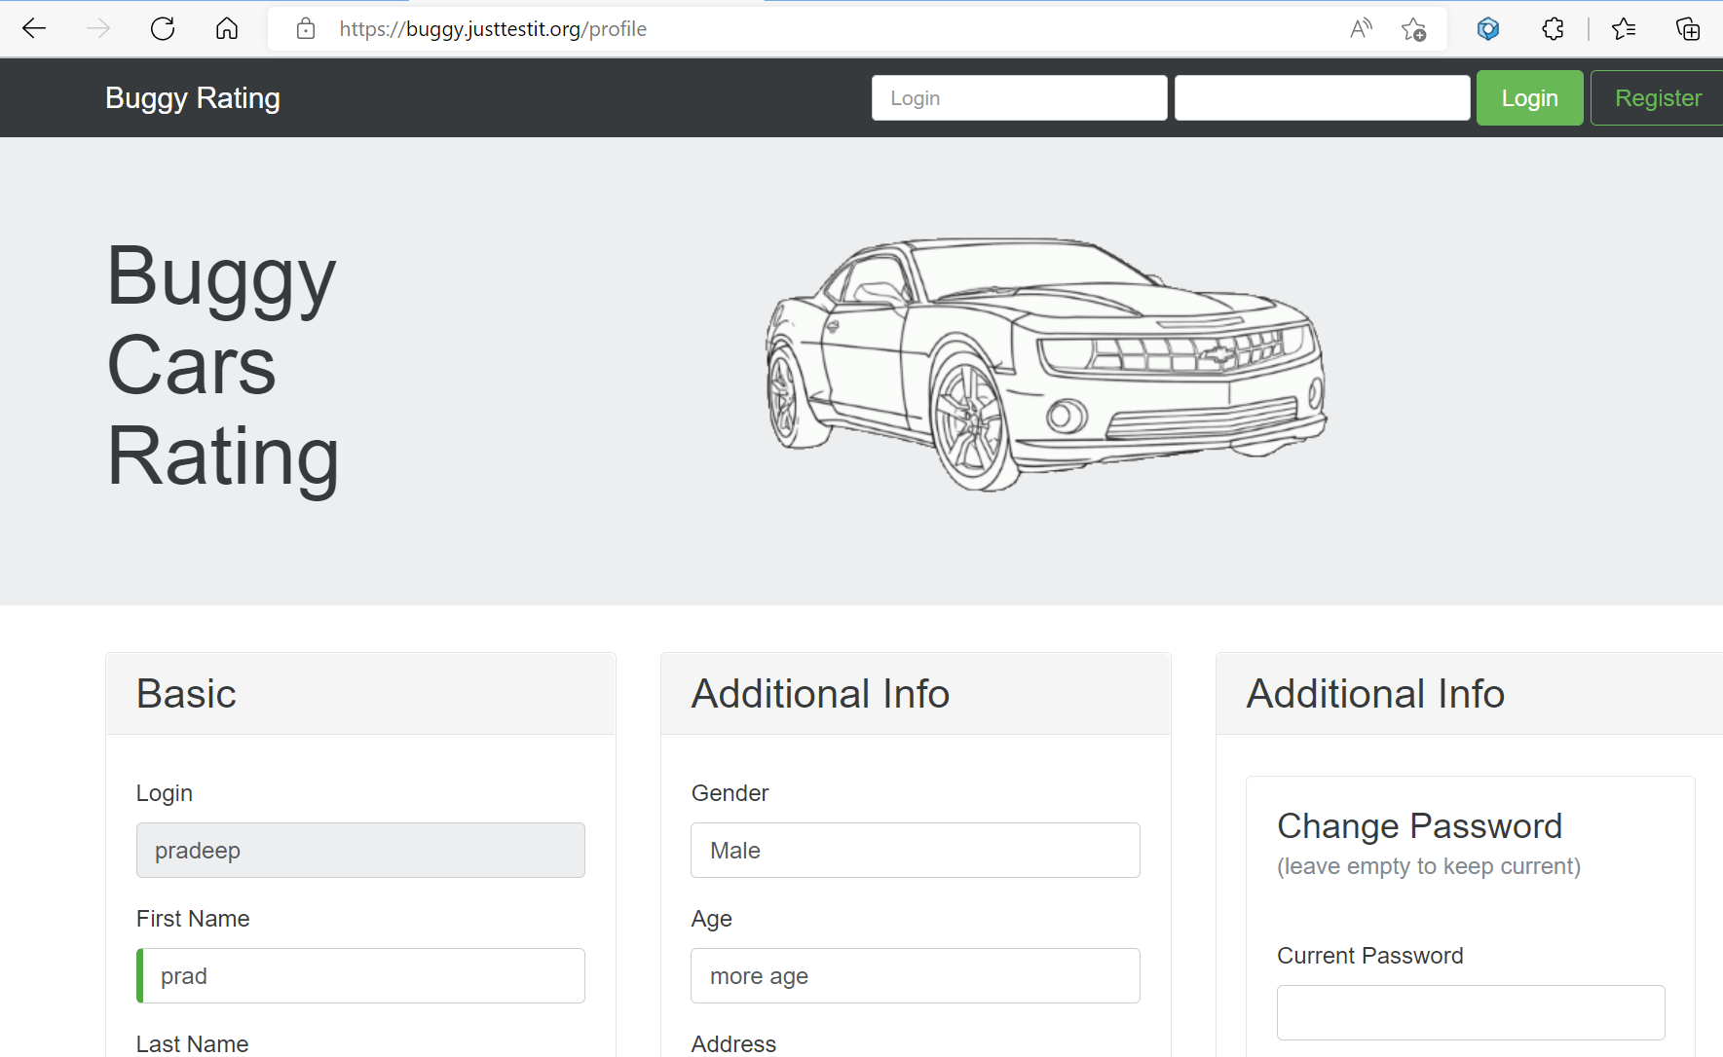

**Bug ID:** 014

**Bug Name:**  Logout on Overall Rating page does not work.

**Severity:** 3-Moderate

**Description:**  
Logout on Overall Rating page does not work.

**Steps To Reproduce:**  
**1)** Visit to <https://buggy.justtestit.org/> and login.  
**2)** Click on the “Overall Rating”.

**3) Click logout**.

**Expected Result:** Should be able to logout successfully.

**Actual Result:** Gives java script error.

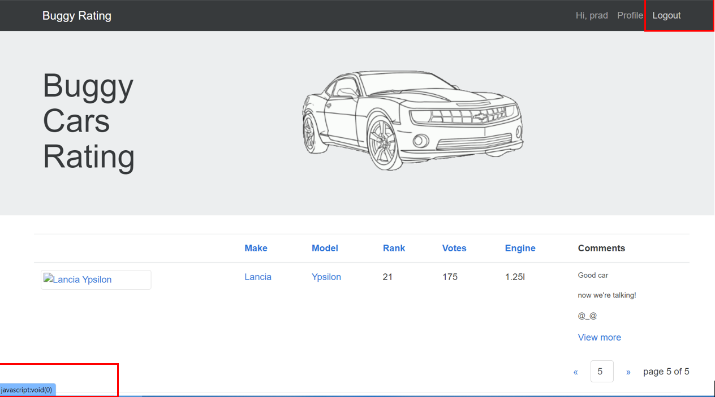

**Bug ID:** 015

**Bug Name:**  Same Username is allowed to register.

**Severity:** 3-Moderate

**Description:**  
Multiple username with same is allowed to register.

**Steps To Reproduce:**  
**1)** Visit to <https://buggy.justtestit.org/> and click Register.  
**2)** Fill out the Field and click Register”.

**3) Once again fill out the same username and click register**.

**Expected Result:** Should have shown error of Same username exist in database.

**Actual Result: Lets user create same username again.**

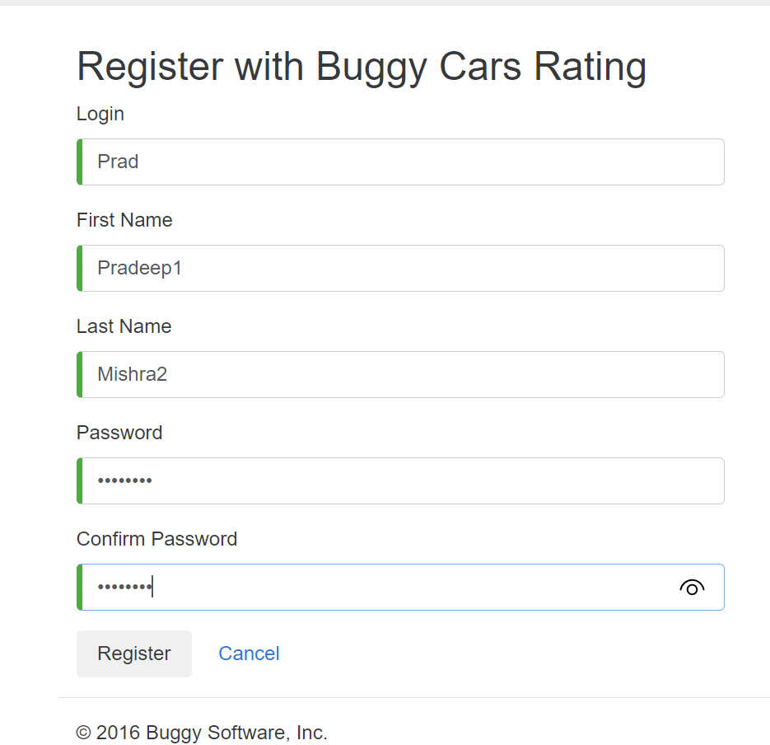

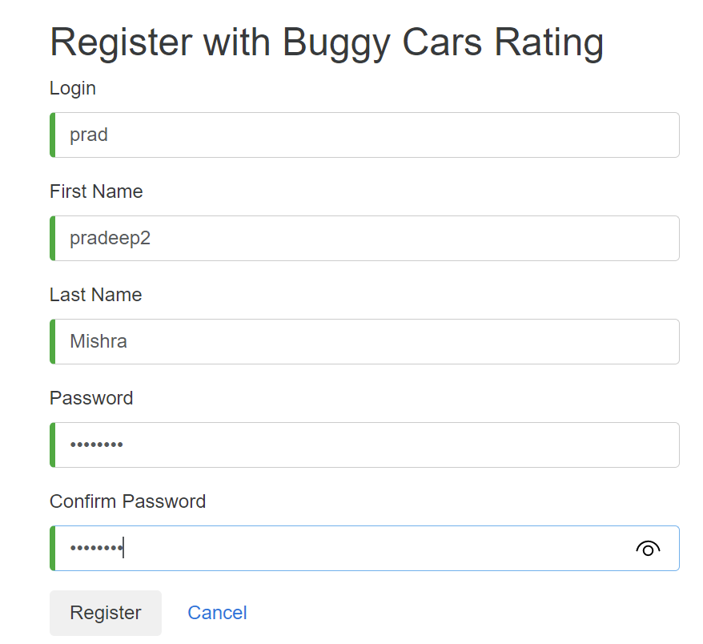

**Bug ID:** 016

**Bug Name:**  Car “Lancia Ypsilon” image does not display.

**Severity:** 4-Minor

**Description:**  
Image of car “Lancia Ypsilon” does not display.

**Steps To Reproduce:**  
**1)** Visit to <https://buggy.justtestit.org/> and login.  
**2)** Click on the “Overall Rating”.

**3) Click >> 4 times to go last page**.

**Expected Result:** Image of car “Lancia Ypsilon” should display.

**Actual Result:** Image of car “Lancia Ypsilon” does not display.

